Republic of the Philippines

National Police Commission

Philippine National Police

**Cavite Police Provincial Office**

**CARMONA MUNICIPAL POLICE STATION**

Brgy Maduya, Carmona, Cavite

***carmonacavitepnp@gmail.com***

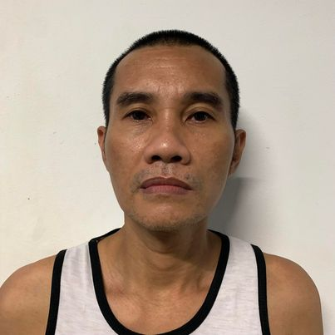

April 5, 2022

**CERTIFICATE OF DETENTION**

**TO WHOM IT MAY CONCERN**

**THIS IS TO CERTIFY** that one **RICARDO ESCARILLA GALLANO**, male, 45 years old, born on **January 18, 1977**, single, resident of **B8 L159 Area G. Brgy. Poblacion 5, GMA, Cavite** was detained at this office since March 9, 2022 up to present and charged for the crime of **“Theft”** with Docketed No.: **IV-03-INQ-22C-**

**1133-E-INQ,** before the Office of Provincial Prosecutor, Imus, Cavite.

This certification is being issued upon request of interested party for whatever legal purposes it may serve.

Prepared by :

Ricardo Gallano, **PSSg Anderson A Videña**

Detainee Custodial Officer